I
n this session we will come to know what is process application and implement process application maven project.

Process application is an ordinary Java application that uses a shared Camunda BPM engine in a Servlet Container, e.g. Apache Tomcat. Contains: Servlet Process Application, BPMN Process, Java Delegate, HTML5-based start and task forms, JUnit Test with in-memory engine, Maven Plugins or Ant build script for one-click deployment in Eclipse

Camunda Process Application

Most such applications will start their own process engine (or use a process engine provided by the runtime container), deploy some BPMN 2.0 process definitions and interact with process instances derived from these process definitions.

Create Maven Project.
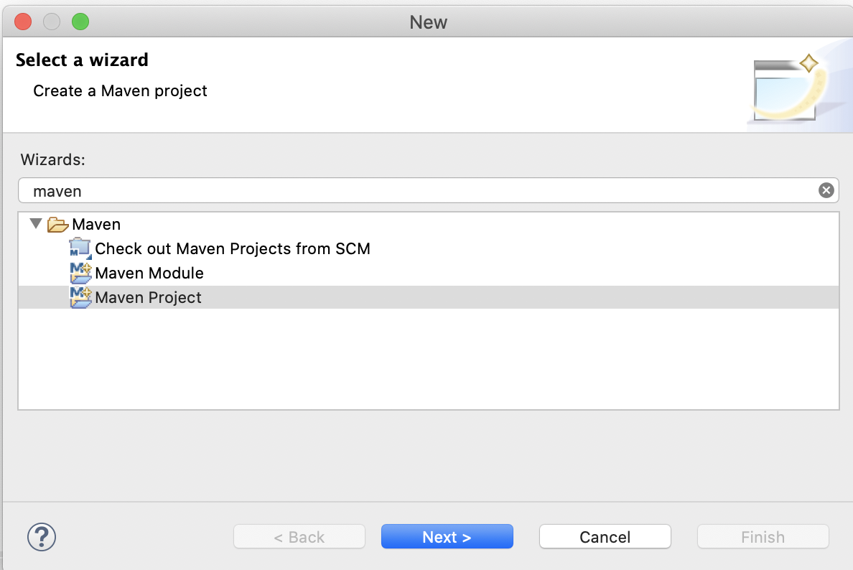
Hit the Next > button.

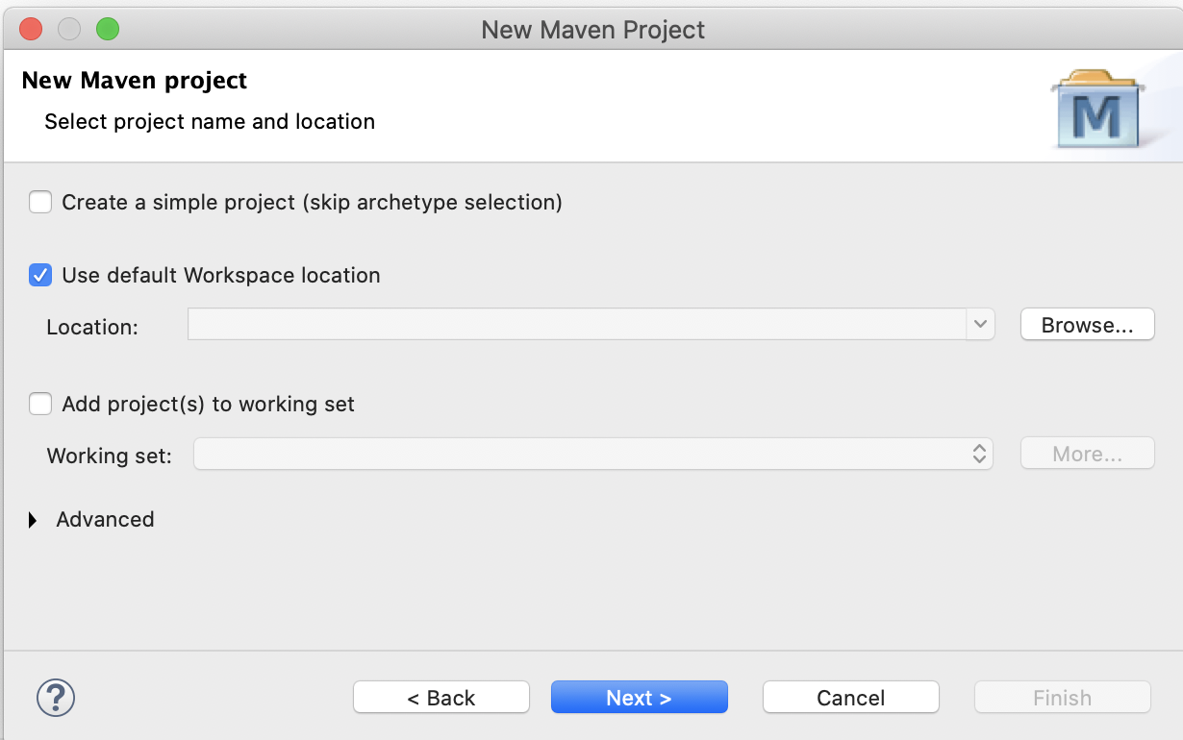
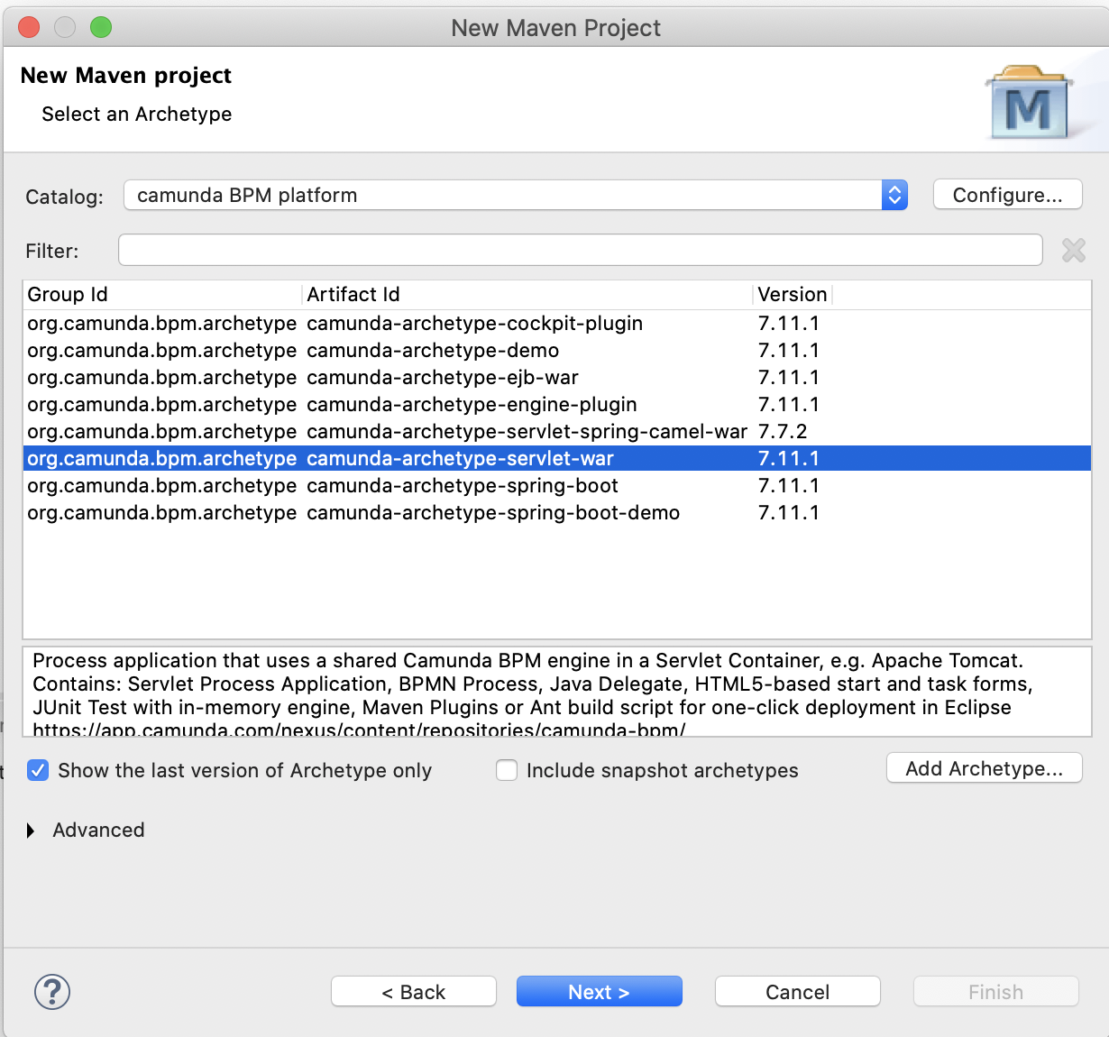
Hit the Next > button.

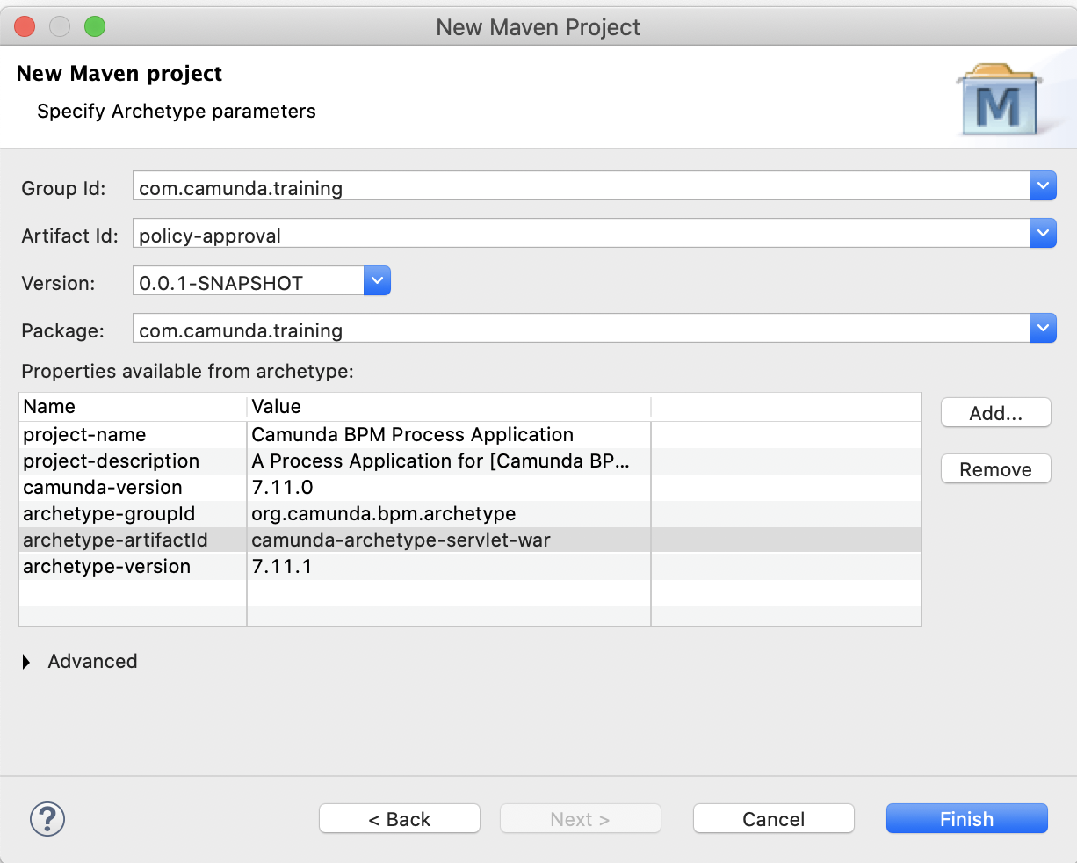
Select camunda-archetype -servlet-war and hit the Next > button.

Group Id: com.camunda.training
Artifact-Id: policy-approval
Version: 0.0.1-SNAPSHOT
Package: com.camunda.training

Hit the Finish button.

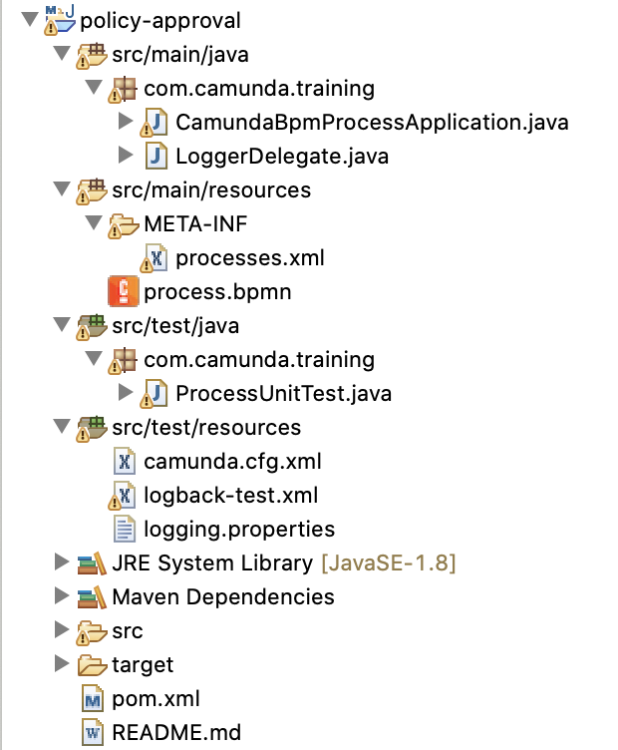
Eclipse camunda maven project created as below.

As we are using camunda version 7.14.0. we need to update maven camunda dependency to 7.14.0.

Open pom.xml and update

<camunda.version>7.11.0</camunda.version> to <camunda.version>7.14.0</camunda.version>

Add dependency for

<!-- https://mvnrepository.com/artifact/joda-time/joda-time -->
<dependency>
<groupId>joda-time</groupId>
<artifactId>joda-time</artifactId>
</dependency>

Updated pom.xml looks like below.

<?xml version="1.0" encoding="UTF-8"?>
<project xmlns="http://maven.apache.org/POM/4.0.0" xmlns:xsi="http://www.w3.org/2001/XMLSchema-instance" xsi:schemaLocation="http://maven.apache.org/POM/4.0.0 http://maven.apache.org/xsd/maven-4.0.0.xsd">
<modelVersion>4.0.0</modelVersion>

<groupId>com.camunda.training</groupId>
<artifactId>policy-approval</artifactId>
<version>0.0.1-SNAPSHOT</version>

<packaging>war</packaging>

<name>Camunda BPM Process Application</name>
<description>A Process Application for [Camunda BPM](http://docs.camunda.org). [The project has been generated by the Maven archetype 'camunda-archetype-servlet-war-7.11.1']</description>

<properties>
<camunda.version>7.14.0</camunda.version>
<!--
Adjust if you want to use Camunda Enterprise Edition (EE):
<camunda.version>7.11.0-ee</camunda.version>
Make sure you also switch to EE repository below
-->
<maven.compiler.source>1.8</maven.compiler.source>
<maven.compiler.target>1.8</maven.compiler.target>
<project.build.sourceEncoding>UTF-8</project.build.sourceEncoding>
<failOnMissingWebXml>false</failOnMissingWebXml>
</properties>

<dependencyManagement>
<dependencies>
<dependency>
<groupId>org.camunda.bpm</groupId>
<artifactId>camunda-bom</artifactId>
<version>${camunda.version}</version>
<scope>import</scope>
<type>pom</type>
</dependency>
</dependencies>
</dependencyManagement>

<dependencies>
<dependency>
<!-- process engine, needs to be 'provided' because it's already a shared library in the container -->
<groupId>org.camunda.bpm</groupId>
<artifactId>camunda-engine</artifactId>
<scope>provided</scope>
</dependency>

<dependency>
<!-- AssertJ Testing Library -->
<groupId>org.camunda.bpm.extension</groupId>
<artifactId>camunda-bpm-assert</artifactId>
<version>1.2</version>
<scope>test</scope>
</dependency>

<!-- Required to use Spin dataformat support in unit tests -->
<dependency>
<groupId>org.camunda.spin</groupId>
<artifactId>camunda-spin-dataformat-all</artifactId>
<scope>test</scope>
</dependency>
<dependency>
<groupId>org.camunda.bpm</groupId>
<artifactId>camunda-engine-plugin-spin</artifactId>
<scope>test</scope>
</dependency>

<!-- Required to use Templates in unit tests -->
<dependency>
<groupId>org.camunda.template-engines</groupId>
<artifactId>camunda-template-engines-freemarker</artifactId>
<scope>test</scope>
</dependency>
<dependency>
<groupId>org.camunda.template-engines</groupId>
<artifactId>camunda-template-engines-velocity</artifactId>
<scope>test</scope>
</dependency>

<dependency>
<groupId>javax.servlet</groupId>
<artifactId>javax.servlet-api</artifactId>
<version>3.1.0</version>
<scope>provided</scope>
</dependency>

<dependency>
<groupId>junit</groupId>
<artifactId>junit</artifactId>
<version>4.12</version>
<scope>test</scope>
</dependency>

<dependency>
<!-- Needed for InMemoryH2Test -->
<groupId>com.h2database</groupId>
<artifactId>h2</artifactId>
<version>1.4.197</version>
<scope>test</scope>
</dependency>

<dependency>
<!-- Used to generate test coverage reports, see https://github.com/camunda/camunda-consulting/tree/master/snippets/camunda-bpm-process-test-coverage -->
<groupId>org.camunda.bpm.extension</groupId>
<artifactId>camunda-bpm-process-test-coverage</artifactId>
<version>0.3.2</version>
<scope>test</scope>
</dependency>

<!-- https://mvnrepository.com/artifact/joda-time/joda-time -->
<dependency>
<groupId>joda-time</groupId>
<artifactId>joda-time</artifactId>
</dependency>

<dependency>
<!-- use logback as logger -->
<groupId>ch.qos.logback</groupId>
<artifactId>logback-classic</artifactId>
<version>1.1.3</version>
<scope>test</scope>
</dependency>

<dependency>
<groupId>org.slf4j</groupId>
<!-- apache commons logging => slf4j -->
<artifactId>jcl-over-slf4j</artifactId>
<version>1.7.25</version>
<scope>test</scope>
</dependency>

<dependency>
<!-- java util logging => slf4j -->
<groupId>org.slf4j</groupId>
<artifactId>jul-to-slf4j</artifactId>
<version>1.7.25</version>
<scope>test</scope>
</dependency>

<!-- Add your own dependencies here, if in compile scope, they are added to the war -->

</dependencies>

<repositories>
<repository>
<id>camunda-bpm-nexus</id>
<name>Camunda Maven Repository</name>
<url>https://app.camunda.com/nexus/content/groups/public</url>
</repository>
<!-- enable this for EE dependencies (requires credentials in ~/.m2/settings.xml)
<repository>
<id>camunda-bpm-nexus-ee</id>
<name>Camunda Enterprise Maven Repository</name>
<url>https://app.camunda.com/nexus/content/repositories/camunda-bpm-ee</url>
</repository>
-->
</repositories>

<build>
<finalName>${project.artifactId}</finalName>
<plugins>
<plugin>
<!-- Deploy to Tomcat using: mvn clean package antrun:run
Follow the instructions in build.properties.example to make it work!-->
<groupId>org.apache.maven.plugins</groupId>
<artifactId>maven-antrun-plugin</artifactId>
<configuration>
<tasks>
<ant antfile="${basedir}/build.xml">
<target name="copy.war.into.tomcat" />
</ant>
</tasks>
</configuration>
</plugin>
<!-- Tomcat Maven Plugin

Deploy to Tomcat using:
mvn clean tomcat7:deploy

Redeploy:
mvn clean tomcat7:redeploy

Undeploy:
mvn tomcat7:undeploy

To use this plugin, add these lines to your tomcat-users.xml: (inside the <tomcat-users>-tag)
<role rolename="manager-script"/>
<user username="admin" password="admin" roles="manager-script"/>

-->
<plugin>
<groupId>org.apache.tomcat.maven</groupId>
<artifactId>tomcat7-maven-plugin</artifactId>
<version>2.2</version>
<configuration>
<url>http://localhost:8080/manager/text</url>
<username>admin</username>
<password>admin</password>
</configuration>
</plugin>
<plugin>
<!-- Deploy to JBoss AS7: mvn clean jboss-as:deploy See also: https://docs.jboss.org/jbossas/7/plugins/maven/latest/examples/deployment-example.html -->
<groupId>org.jboss.as.plugins</groupId>
<artifactId>jboss-as-maven-plugin</artifactId>
<version>7.9.Final</version>
</plugin>
<plugin>
<!-- Deploy to Wildfly: mvn clean wildfly:deploy See also: https://docs.jboss.org/wildfly/plugins/maven/latest/examples/deployment-example.html -->
<groupId>org.wildfly.plugins</groupId>
<artifactId>wildfly-maven-plugin</artifactId>
<version>1.2.1.Final</version>
</plugin>
</plugins>
</build>
</project>

Now let’s update process.bpmn as below.
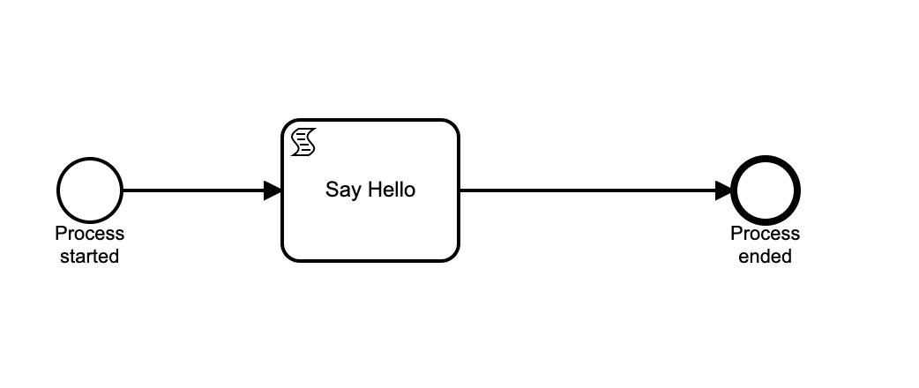
Script task : Say Hello
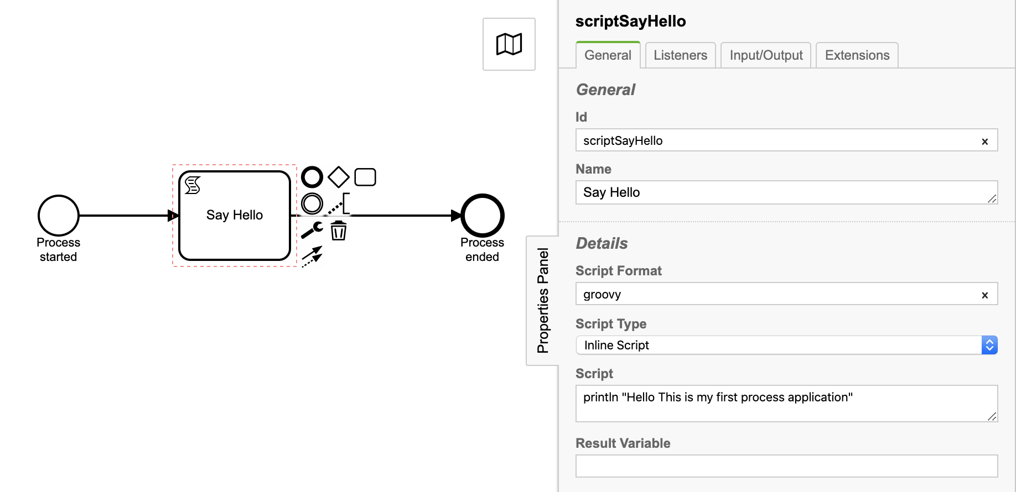

Properties:
Id: scriptSayHello
Name: Say Hello
Script Format: groovy
Script Type: Inline Script
Script: println "Hello This is my first process application”

Now generate build and deploy to camunda tomcat server.

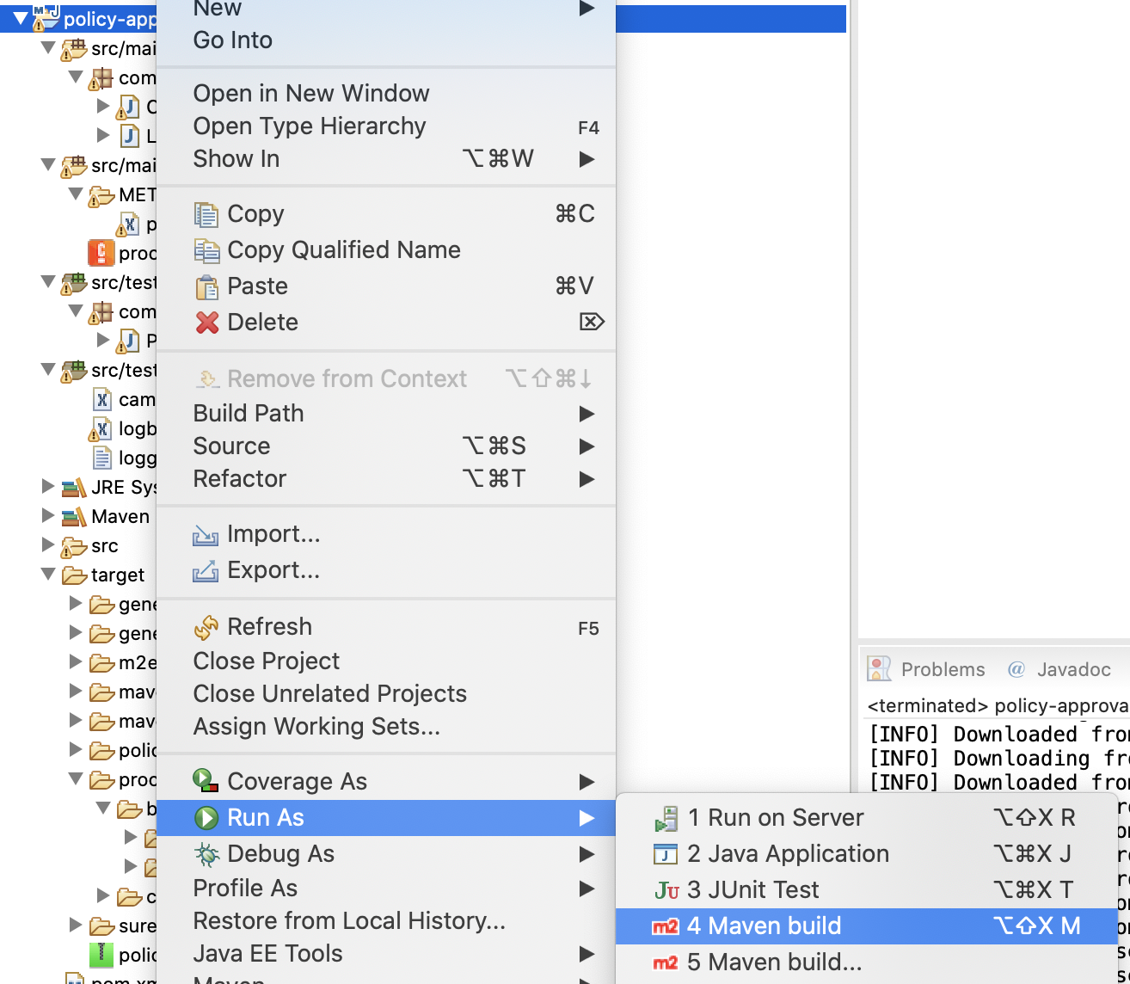
Right click on project—> Run As—> Maven build

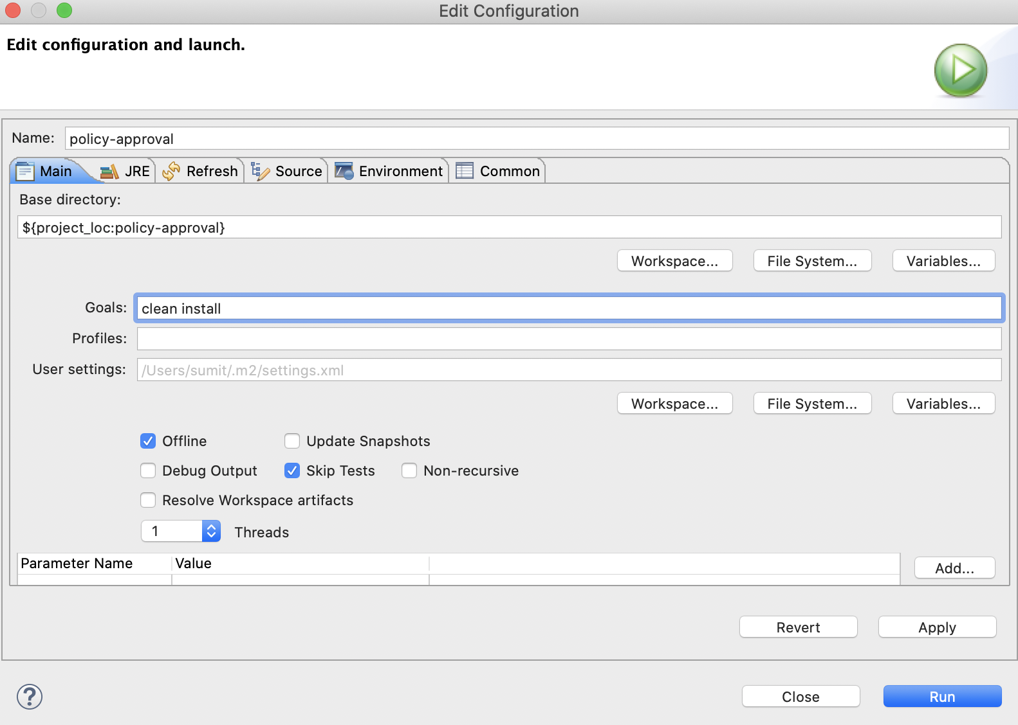

Goals: clean install
Click check boxes: Offline and Skip Tests

Then hit the Run button. This will generate policy-approval.war into target folder as per below screen.
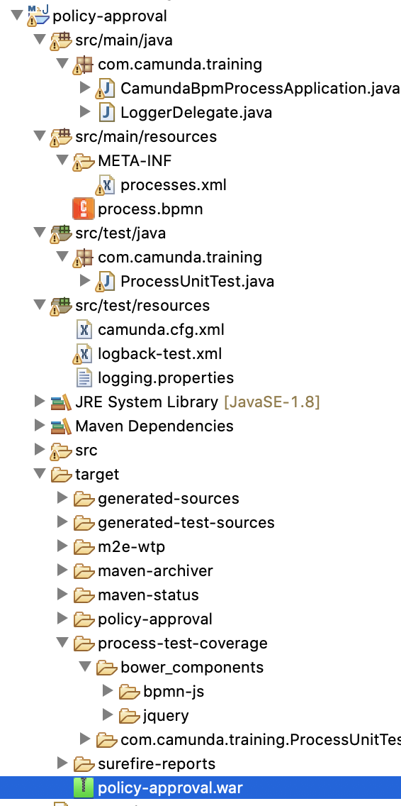
Deploy generated policy-approval.war to camunda-bpm-tomcat-7.13.0/server/apache-tomcat-9.0.33/webapps directory.
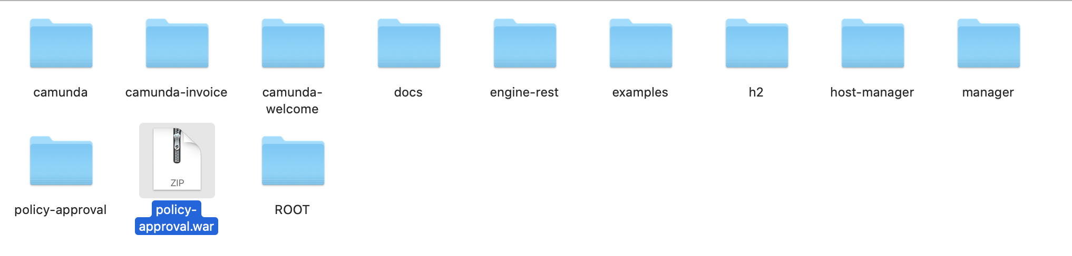
policy-approval.war will be deployed and can be verified from tomcat console log

29-Aug-2020 09:40:49.571 INFO [Catalina-utility-1] org.camunda.commons.logging.BaseLogger.logInfo ENGINE-08050 Process application policy-approval successfully deployed

Now let’s see deployed application through camunda Cockpit web application.

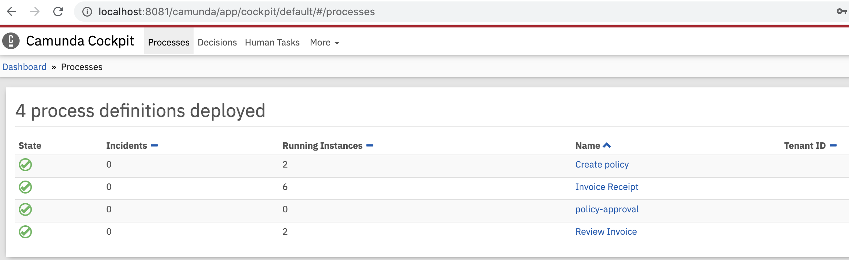
Processes:

Deployments:
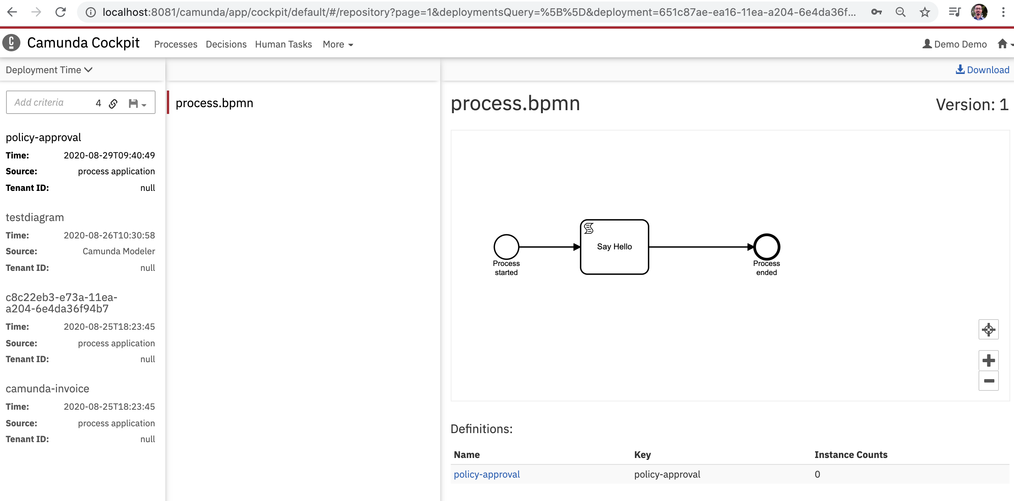

Let run the deployed process through camunda tasklist web application.
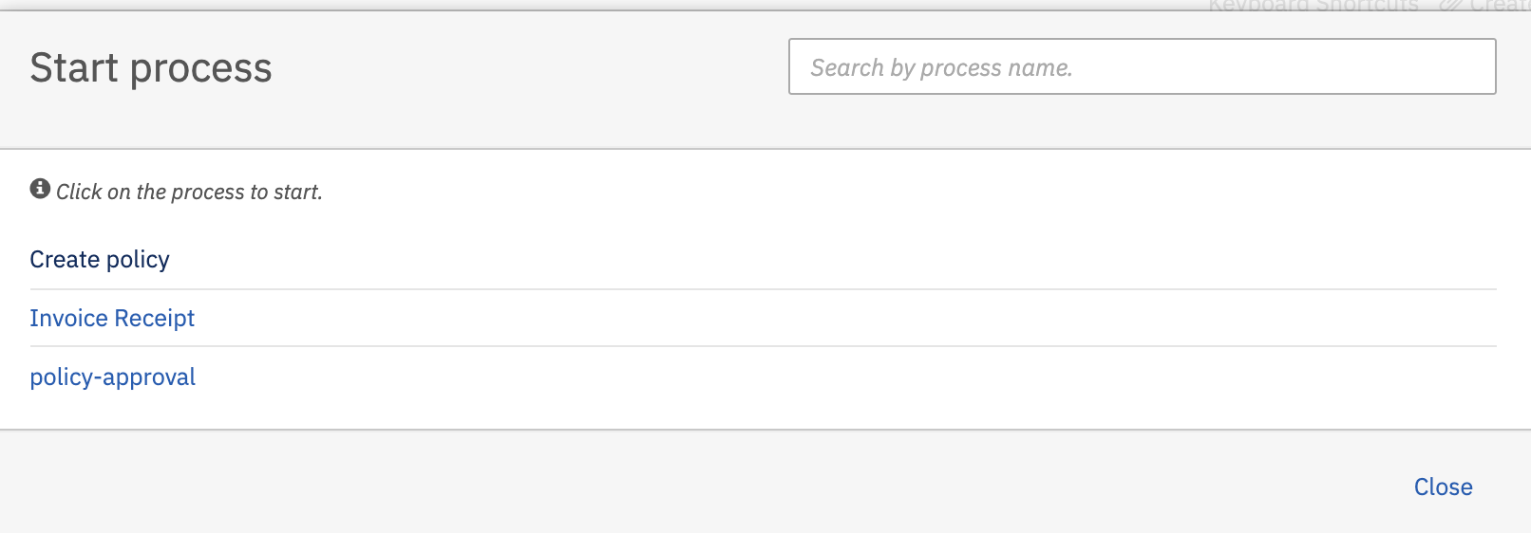
Hit the poilcy-approval and then hit the start button to start process.

Observe the tomcat console log to verify process is started and script task is executed.

29-Aug-2020 09:40:49.579 INFO [Catalina-utility-1] org.apache.catalina.startup.HostConfig.deployWAR Deployment of web application archive [/Volumes/Trainings/Camunda/Softwares/camunda-bpm-tomcat-7.13.0/server/apache-tomcat-9.0.33/webapps/policy-approval.war] has finished in [3,289] ms
Hello This is my first process applcation

Now let’s understand the process application components.

CamundaBpmProcessApplication.java

The Process Application class constitutes the interface between your application and the process engine.

@ProcessApplication
public class CamundaBpmProcessApplication extends ServletProcessApplication {
private static final String PROCESS_DEFINITION_KEY = "policy-approval";
/**
* In a @PostDeploy Hook you can interact with the process engine and access
* the processes the application has deployed.
*/
@PostDeploy
public void onDeploymentFinished(ProcessEngine processEngine) {}
}

processes.xml

The last step to set up the process application is to add the META-INF/processes.xml deployment descriptor file. This file allows us to provide a declarative configuration of the deployment(s) this process application makes to the process engine.

<?xml version="1.0" encoding="UTF-8"?>
<process-application
xmlns="http://www.camunda.org/schema/1.0/ProcessApplication"
xmlns:xsi="http://www.w3.org/2001/XMLSchema-instance">

<process-archive>
<process-engine>default</process-engine>
<properties>
<property name="isDeleteUponUndeploy">false</property>
<property name="isScanForProcessDefinitions">true</property>
</properties>
</process-archive>

</process-application>

